**28th July – 4th August**

**Trinity 9**

www.shirleyparishb90.co.uk

office@shirleyparishb90.co.uk

0121 745 8896

Church House, Church Road,

Shirley, B90 2AX

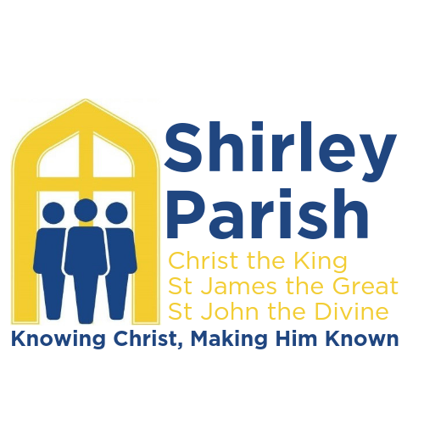

**Sun 28th** 8am Eucharist (St James)

9am Eucharist (St John’s)

10:30am Worship 4 Everyone (St James and YouTube)

10.30am Eucharist (Christ the King)

12.30pm Baptism (St James)

**Mon 29th** 12.30pm Funeral (St James)

**Tues 30th**  10am Welcome Café (Church House)

11.30am Craft Club (Church House)

**Thurs 1st** 10:30am Eucharist (St James)

**Sat 3rd** 9am Parish Prayers (zoom)

**Sun 4th** 10:30am Eucharist (St James and YouTube)

6pm Reflective Service (St James)

**Rev Paul Day - Vicar**

0121 537 9672

vicar@shirleyparishb90.co.uk

(Rest Day is Monday)

**Rev Richard Haynes - Curate**

0797 253 0161

curate@shirleyparishb90.co.uk

(Rest Day is Friday)

**Rev Rich Brooker – Curate**

07922 564696

[richbrooker@shirleyparishb90.co.uk](mailto:richbrooker@shirleyparishb90.co.uk)

(rest day is Friday)

**For Prayer –** Our Lady Of the Wayside Catholic Church

**Those Who Have Died –**

**Years Mind -**

Kathleen Simmons, Mabel Harris, Thomas Boulton, Josiah Coupe, Nichola Mellor, Doris Davies, Norman Reginald Blythe, Murial Sellers, Gary Denyer, Catherine Grogan, Helen Watts and Leonard Rudge

**Parish Notices**

**Parish Office** Please remember the office is **closed to visitors** on Mondays.

**Holidays** – Rich B is away from 13th – 28th July; Paul is away from 22nd July – 5th Aug; Richard H is away from 12th – 20th Aug.

**Recycling** - Please be aware of the "Simpler Recycling" article in this month's magazine - it applies to Church House and to our churches.

**Mothers Union** Our next meeting will be on **Thursday 1st August.** It is an **evening** meeting, **starting at 7.30.** It will be Desert Island Discs with castaways Rev Richard and Ruth Haynes. Visitors are welcome to our meetings.

**Pod Project** - St James School held a sponsored fun run in the last week of term to raise funds for the Pod Project. At the end of term service we were gobsmacked to receive a certificate to say the school had raised a staggering £3257. Many many thanks to all children, staff and parents!!

**A copy of the Deanery Newsletter** can be found here [KNMS Deanery newsletter - June & July 2024.pdf](https://1drv.ms/b/c/c9d31fefe29e54b9/EZ_r7fvBKshPiv0niRocInUBnmcJlAjx4zm2jhc9KqagPA?e=9atJDd)

**THANK YOU!! -** A huge thank you to everybody who has supported me at the ordination to priest. I am grateful for all of your prayers, cards and gifts. It was brilliant to celebrate the occasion with so many of you at the cathedral, in church house and in spirit. With love, thanks and blessings Richard

YouTube: YouTube.com/@shirleyparish5736 Facebook: Shirley Parish B90 Zoom: us02web.zoom.us/j/4904334906

**Coming up…**

**Coffee Morning** - Monday 12th August, 10.30am to 12 noon at St John's Church, all welcome

**Collect –**

Almighty God, who sent your Holy Spirit to be the life and light of your Church: open our hearts to the riches of your grace, that we may bring forth the fruit of the Spirit in love and joy and peace; through Jesus Christ your Son our Lord, who is alive and reigns with you, in the unity of the Holy Spirit, one God, now and for ever.

**Readings for Sunday 28th July**

**2 Kings 4.42 – end**

A man came from Baal-shalishah, bringing food from the first fruits to the man of God: twenty loaves of barley and fresh ears of grain in his sack. Elisha said, ‘Give it to the people and let them eat.’ But his servant said, ‘How can I set this before a hundred people?’ So he repeated, ‘Give it to the people and let them eat, for thus says the Lord, “They shall eat and have some left.” ’ He set it before them, they ate, and had some left, according to the word of the Lord.

**Ephesians 3.14 – end**

For this reason I bow my knees before the Father, from whom every family in heaven and on earth takes its name. I pray that, according to the riches of his glory, he may grant that you may be strengthened in your inner being with power through his Spirit, and that Christ may dwell in your hearts through faith, as you are being rooted and grounded in love. I pray that you may have the power to comprehend, with all the saints, what is the breadth and length and height and depth, and to know the love of Christ that surpasses knowledge, so that you may be filled with all the fullness of God. Now to him who by the power at work within us is able to accomplish abundantly far more than all we can ask or imagine, to him be glory in the church and in Christ Jesus to all generations, for ever and ever. Amen.

**John 6.1 – 21**

After this, Jesus went across Lake Galilee (or, Lake Tiberias, as it is also called). A large crowd followed him, because they had seen his miracles of healing the sick. Jesus went up a hill and sat down with his disciples. The time for the Passover Festival was near. Jesus looked around and saw that a large crowd was coming to him, so he asked Philip, “Where can we buy enough food to feed all these people?” (He said this to test Philip; actually he already knew what he would do.) Philip answered, “For everyone to have even a little, it would take more than two hundred silver coin to buy enough bread.” Another one of his disciples, Andrew, who was Simon Peter's brother, said, “There is a boy here who has five loaves of barley bread and two fish. But they will certainly not be enough for all these people.”“Make the people sit down,” Jesus told them. (There was a lot of grass there.) So all the people sat down; there were about five thousand men.Jesus took the bread, gave thanks to God, and distributed it to the people who were sitting there. He did the same with the fish, and they all had as much as they wanted.When they were all full, he said to his disciples, “Gather the pieces left over; let us not waste a bit.” So they gathered them all and filled twelve baskets with the pieces left over from the five barley loaves which the people had eaten.Seeing this miracle that Jesus had performed, the people there said, “Surely this is the Prophet who was to come into the world!” Jesus knew that they were about to come and seize him in order to make him king by force; so he went off again to the hills by himself.

Jesus Walks on the Water

When evening came, Jesus' disciples went down to the lake,got into a boat, and went back across the lake toward Capernaum. Night came on, and Jesus still had not come to them. By then a strong wind was blowing and stirring up the water. The disciples had rowed about three or four miles when they saw Jesus walking on the water, coming near the boat, and they were terrified. “Don't be afraid,” Jesus told them, “it is I!”Then they willingly took him into the boat, and immediately the boat reached land at the place they were heading for.

If you wish to contribute to the notice sheet, please contact the Parish Office by 9am Wednesday (max of 3 sentences). Longer articles to shirleyparishmagazine@gmail.com by the 12th